FULL STACK PROJECT REPORT

**On**

**“VOILA”**

**Submitted by**

**Alok Srivastava**

**(191500001)**

**Astha Jaiswal**

**(191500175)**

**Ayushi Gupta**

**(191500205)**

Department of Computer Engineering & Applications

**Institute of Engineering & Technology**



**GLA University**

**Mathura- 281406, INDIA**

**2021-2022**

**Department of computer Engineering and Applications**

**GLA University, Mathura**

**17 km. Stone NH#2, Mathura-Delhi Road, P.O. – Chaumuha,**

**Mathura – 281406**



**Declaration**

We hereby declare that the work which is being presented in the Full Stack Project “**VOILA”,** in partial fulfillment of the requirements for Full Stack Project viva voce, is an authentic record of our own work carried by the team members under the supervision of our mentor Mr. Pankaj Kapoor.

Group Members: Alok Srivastava (191500001)

Astha Jaiswal (191500175)

Ayushi Gupta (191500205)

Course: B.Tech (Computer Science and Engineering)

Year: 3rd

Semester: 5th

## Supervised By:

Mr. Pankaj Kapoor, Assistant Professor,

GLA University, Department of Computer Engineering & Application

**Department of computer Engineering and Applications**

**GLA University, Mathura**

**17 km. Stone NH#2, Mathura-Delhi Road, P.O. – Chaumuha,**

**Mathura – 281406**



**Certificate**

This is to certify that the above statements made by the candidates are correct to the best of my/our knowledge and belief.

_______________________

Supervisor

Mr. Pankaj Kapoor

Technical Trainer

Dept of CEA, GLA University

____________________ ____________________________ Project Coordinator Program Coordinator

(Mr. Mayank Srivastava) (Mr. Shashi Shekar)

**About the Project**

Our full stack project “VOILA” is an on-demand service platform. The platform helps customers book reliable and high quality services – cloud services, beauty treatments, massages, haircuts, home-cleaning, appliance repair, vehicle repair, painting, carpenter, electrician, fitness and more – delivered by trained professionals conveniently at home. To reduce burden in finding in-house solutions, the proposed platform (VOILA) provides users with several services by skilled professionals at your doorstep in just one click. A systematic environment to allow clients have ease in accessing our services in a more comfortable way. With well qualified and background demonstrated professionals we make all your home cleaning, plumbing, furniture maintenance, electrical works, appliance repair, house painting, vehicle service and many other services to be done in a click anytime from anywhere - quickly and efficiently.

**Motivation**

A new age has dawned. Gone are the days when we were faced with the choice of either starting a business or seeking employment and if we chose the latter, it would entail staying with the organization for a long time. The on-demand marketplace has generated a section of society amidst workers that oscillate between working full time for a company and self-employment. The sole reason for the existence of these strata of workers is due to the gap in understanding the difference between the services offered and what is desired.

Large companies charge a fortune for small jobs that might take fifteen minutes to accomplish. A simple quick-fix job like fixing a leak in the plumbing system may set you back by a hundred dollars or more if you use an established service. Although the inherent cost is low, their scale has caused the price to go up exponentially. These companies also function during regular hours, causing homeowners to be bound by the timings set by them. This gap in expectations vs. offers has effectively been fulfilled by the on-demand marketplace that is the most talked-about trend in the industry.

The biggest reason for the success of the on-demand economy is its inherent capability to make everyone happy. Workers need to add financial stability, which they can accomplish by working as an on-demand worker during their time off. Their on-demand employers cater to those who are very busy during the workweek and have no time for themselves. This demand-supply based economy has filled a gap that earlier required a large paycheck to bridge.

With time being in short supply and the advent of the smartphone coupled with the internet, the largest piece of the **on-demand home services** pie has been served to the current generation. More and more millennials acquire information and book services over the internet today. On-demand home services help bridge the gap between offline services and services available online, often acting as intermediaries that provide you services when you need them, efficiently.

What was formerly a luxury is a necessity today. From booking home cleaning services online to finding runners for their laundry to finding home tutors and nannies for children, millennials have outsourced nearly every aspect of their lives. High income and stress at work have contributed to this industry that has now become bigger than the businesses we currently are employed by.

**Requirements**

**a). Software Requirements:**

* Technology Implemented: Full Stack Web Development
* Languages/Technologies Used: Front-End Technologies
* IDE Used: Visual Studio Code
* Web Browser: Google Chrome, Brave
* GitHub: GitHub is a code hosting platform for version control and collaboration. It lets you and others work together on projects from anywhere. GitHub Repository: A GitHub repository can be used to store a development project. It can contain folders and any type of files (HTML, CSS, JavaScript, Documents, Data, Images). A GitHub repository should also include a license file and a README file about the project. A GitHub repository can also be used to store ideas, or any resources that you want to share.
* Visual Studio Code: Visual Studio Code is a free source-code editor made by Microsoft for Windows, Linux and macOS. [7] Features include support for debugging, syntax highlighting, intelligent code completion, snippets, code refactoring, and embedded Git. Users can change the theme, keyboard shortcuts, preferences, and install extensions that add additional functionality. Microsoft has released Visual Studio Code's source code on the VS Code repository of GitHub.com, under the permissive MIT License, while the compiled binaries are freeware.

**b). Hardware Requirements:**

* Operating System: Windows 10, Linux, MacOS
* RAM: 2GB (Browser supported)
* Hardware Devices: Computer System
* Hard Disk: 256GB

**Acknowledgement**

We thank the almighty for giving us the courage and perseverance in completing the project. This project itself is an acknowledgement for all those people who have given us their heartfelt co-operation in making this project a grand success. We extend our sincere thanks to Mr. Pankaj Kapoor, Assistant Professor at “GLA University, Mathura” for providing his valuable guidance at every stage of this project work. We are profoundly grateful towards the unmatched services rendered by him. And last but not least, we would like to express our deep sense of gratitude and earnest thanks giving to our dear parents for their moral support and heartfelt cooperation in doing the main project.

**VOILA**

**Abstract**

In present scenario, people are buried up in a heavy work culture, as everyone is engaged with busy schedules, and hectic tasks which make them deviate from family life. If any issues encounter unexpectedly, it distracts them and makes them choose over the work they have to accomplish primarily. It is important to manage both professional and family life. In such circumstances, every one of us would have fantasized about a kind of house which doesn’t have any leaks in pipes, if it doesn’t have any mess in fixing a furniture and a kind of house which never face any maintenance issues and every one of us have thought that a life would be much better if no point of issue arises in getting a service at your door step and if there is no mess in bargaining a labor for home service. In such situation’s E-Commerce plays a vital role in today’s life as it has so many advantages in our life because it makes convenient in daily life of the people.

The thought is to design and develop a system that provides many services at your doorstep in just one click. A Website that provides variety of services like plumbers, movers and packers, repair persons, cleaners, electricians, painters, taxi service laundry and many more. To make it comfortable for all the users our system also provides a mobile environment which offers ease in accessing our services. A very simple process is carried out to book a service(s), and our system is specialized with providing a confirmation email about the selected service. People can choose the particularity of service required by uploading the image of desired specification. Website is versatile as service can be booked from everywhere to anywhere you desire..

**Contents**

**Acknowledgment…………………………………….........**09

**Abstract…………………………………………………**10

1. **Introduction:**

Introduction........…......12-13

1. **Technologies Used:**

HTML……………………………….15

CSS……………………......................16

Javascript………………………………..............17-18

**3. List of Figures...……………………………………**20-26

**4. Software Testing..............................................................**27-31

**5. Conclusion……………………………………………**32

**6. Bibliography………………………………………….**33

**Chapter 1**

**Introduction**

When someone need aid with small but major household tasks, the trouble arises when service skilled persons are unavailable or the trusted providers are impossible to find, who delivers consistently flawless service on instance. Our online system for household services provides the most expedient and annoys free way to get your domestic work done. We aim to help in providing optimal solutions to all your household troubles with more efficiency, ease and majorly, a delicate touch. A single click system describes booking highly skilled in-house professionals and gets your service done on time. Customers’ overall willingness to pay is significantly and positively correlated with the expectation that fee-based services would be better, and with the belief that “pay for what you get” is the right thing to do [2]. Keeping that in sense our proposed system is basically a marketplace for household services and it is the platform where the rates were standardized and there is no necessitate haggling over prices. Several aspects like painting, pest control, home cleaning, plumbing, electrical works and carpentry services are involved in a system to provide happy and healthy home atmosphere in order to satisfy consumers.

**Chapter 2**

**Technologies Used**

**HTML**

HTML is the standard markup language for creating Web pages. Every website you open in your web browser, from social networks to music services, uses HTML. A look under the hood of any website would reveal a basic HTML code page, written with an HTML structure editor, providing structure for all the page’s components, including its header element, footer element, main content, and other inline elements. When using HTML for your website, you get to control nearly everything on your website. Because you build your website from the core using a markup language, accessing, and modifying the code is easier than with WordPress. This makes it much more flexible when integrating certain additional features.

**CSS**

CSS is the language we use to style a Web page. With CSS, we are able to create rules, and apply those rules to many elements within the website. This approach offers many advantages when site-wide changes are required by a client. Since the content is completely separated from the design, we can make those changes in our Style Sheet and have it effect every applicable instance.

Since rules are only downloaded once by the browser, then are cached and used for each page load, the use of CSS can lead to lighter page loads, and improved performance.

This contributes to lighter server load and lower requirements, which overall saves money for our clients. It allows one to adapt the presentation to different types of devices, such as large screens, small screens, or printers. CSS is independent of HTML and can be used with any XML-based markup language.

**Javascript**

JavaScript is a text-based programming language used both on the client-side and server-side that allows you to make web pages interactive.

JavaScript enables dynamic interactivity on websites when it is applied to an HTML document. JavaScript helps the users to build modern web applications to interact directly without reloading the page every time. JavaScript is commonly used to dynamically modify HTML and CSS to update a user interface by the DOM API. It is mainly used in web applications.

**Pre-requisite**

Hands-on knowledge of JavaScript, HTML and CSS is essential before working on the concepts for making of webpages. Make sure that you have the browser or chrome installed and running before opening website.

And knowledge about how to use Github is a must, and Git commands. Also, we have to make our website live on Github server, and also have to maintain our whole project on Github, so knowledge of it is very necessary.

**Chapter 3**

**List of Figures**

**1. REGISTER Page**

**(i) Head, Navbar and Sign-up form**

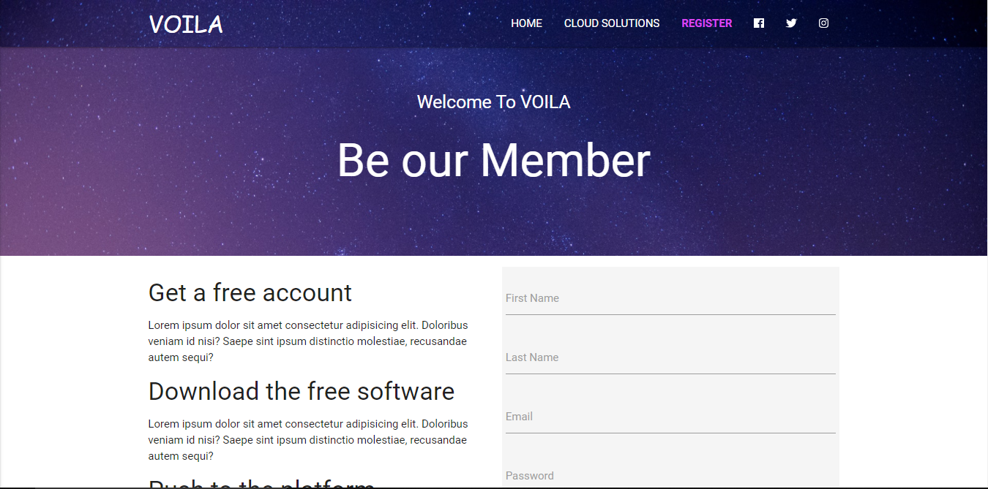

**(ii) Sign-up form and Footer**

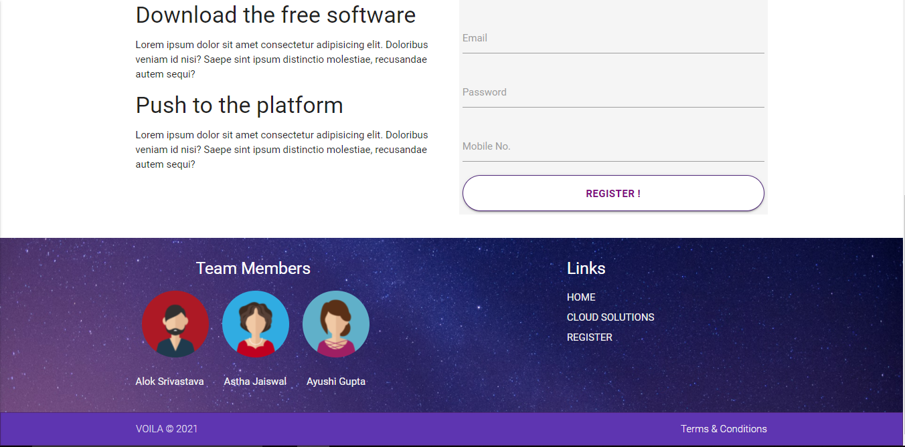

**2. CLOUD SOLUTIONS Page**

**(i) Navbar and Head**

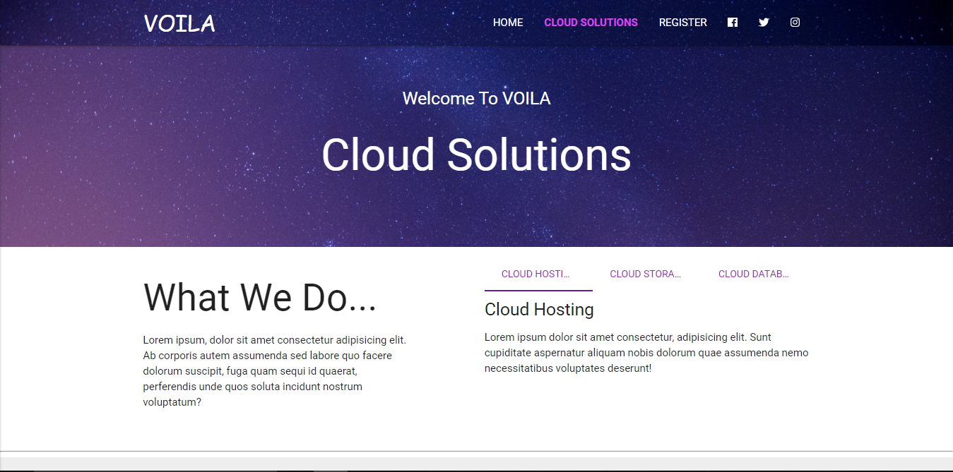

**(ii) Section-2**

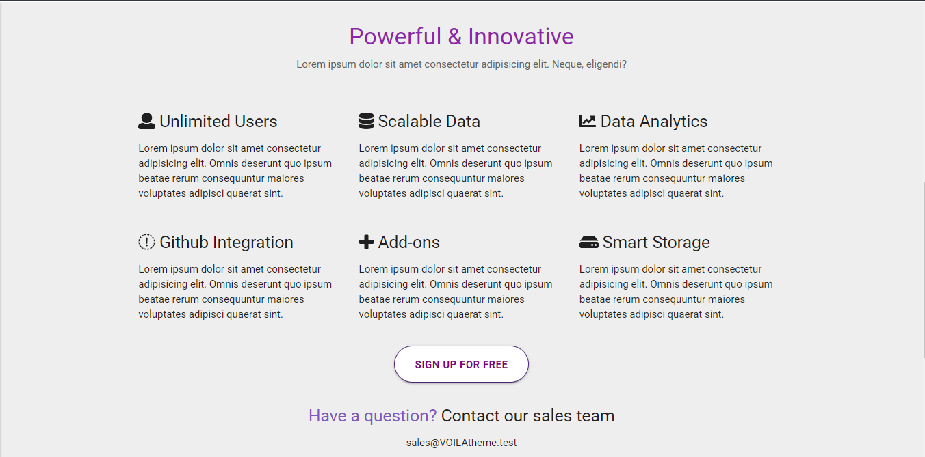

**3. HOME page**

**(i) Navbar and Head**

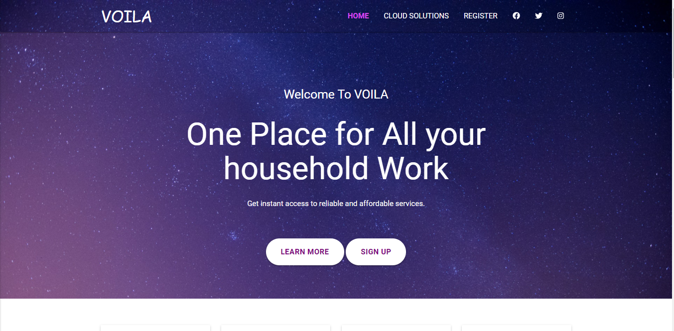

**(ii) Cards Section**

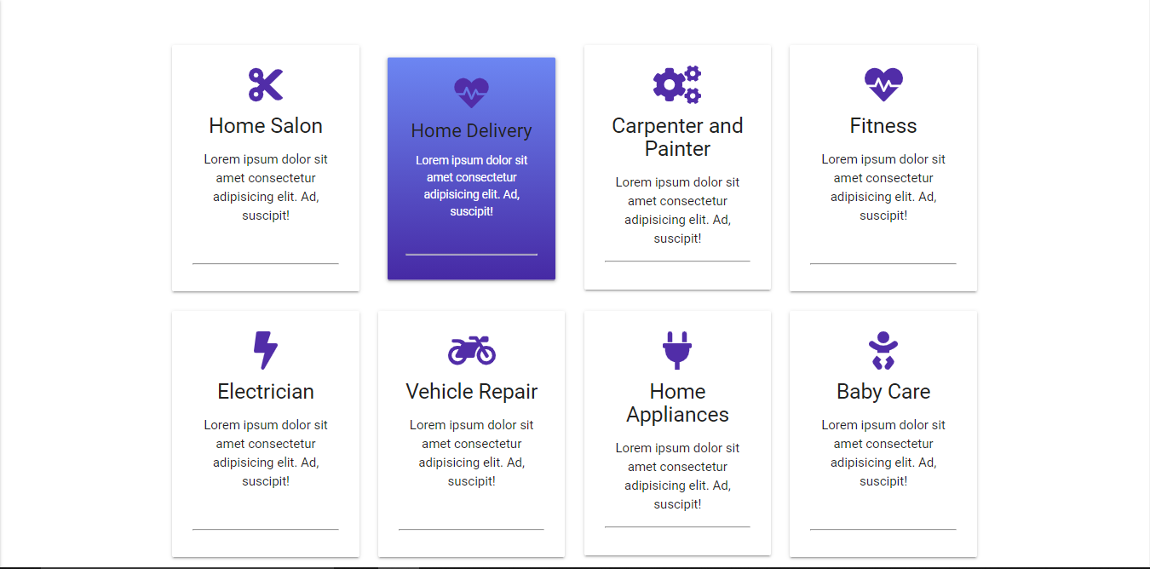

**(iii) About Us Section**

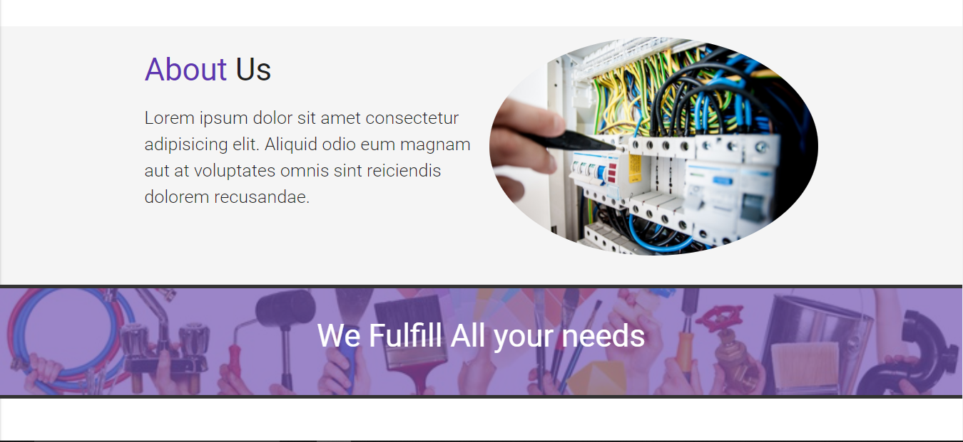

**(iv) Icons and Testimonial**

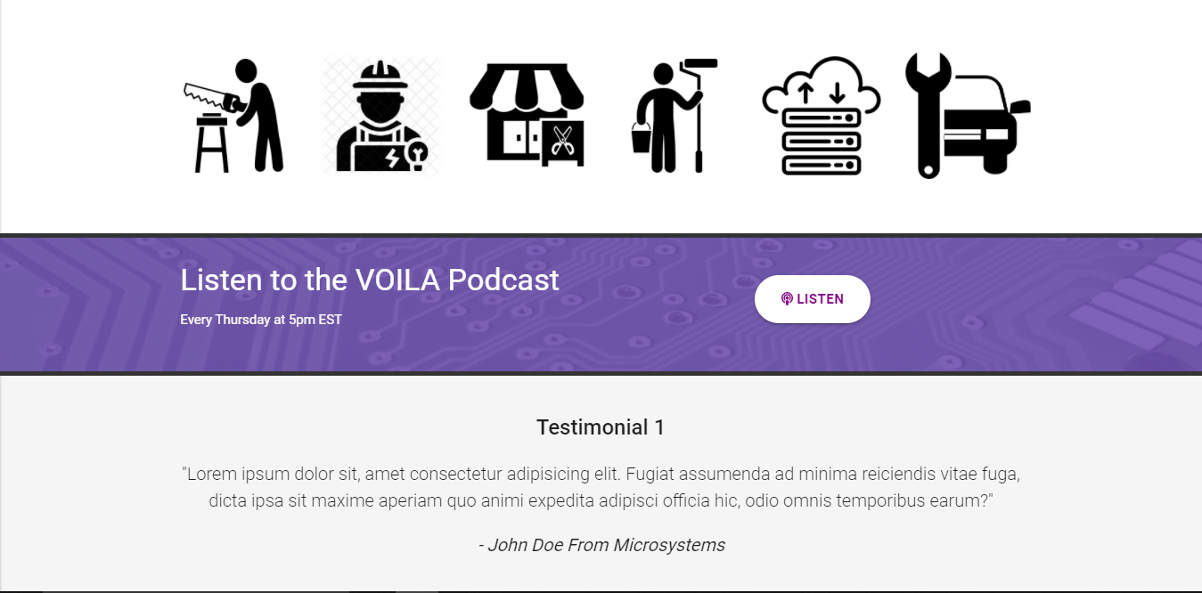

**(v) Footer**

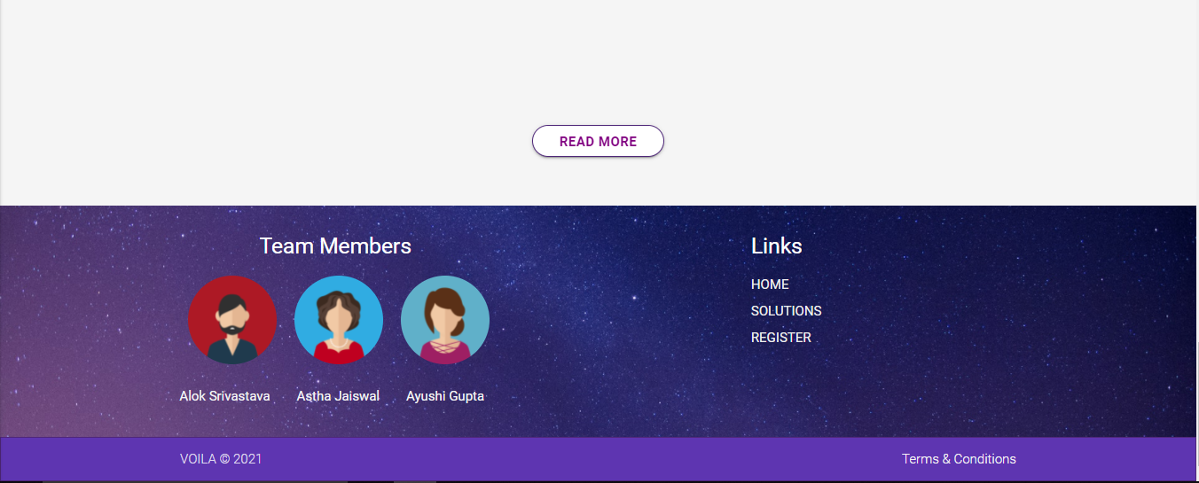

**Chapter 4**

**Software Testing**

Once source code has been generated, software must be tested to uncover as many errors as possible before delivery. It is very important to work the system successfully and achieve high quality of software. Testing include designing a series of test cases that have a high likelihood of finding errors by applying software-testing techniques. System testing makes logical assumptions that if all the parts of the system are correct, the goal will be successfully achieved. The system should be checked logically. Validations and cross checks should be there. Avoid duplications of record that cause redundancy of data. In other Words, Testing is the process of evaluating a system or its component(s) with the intent to find whether it satisfies the specified requirements or not. It is executing a system in order to identify any gaps, errors, or missing requirements in contrary to the actual requirements.

The preliminary goal of implementation is to write source code and internal documentation so that conformance of the code to its specifications can be easily verified, and so that debugging, testing and modifications are eased. This goal can be achieved by making the source code as clear and straightforward as possible. Simplicity, clarity and elegance are the hallmark of good programs, obscurity, cleverness, and complexity are indications of inadequate design and misdirected thinking. Source code clarity is enhanced by structured coding techniques, by good coding style, by, appropriate supporting documents, by good internal comments, and by feature provided in modern programming languages. The implementation team should be provided with a well-defined set of software requirement, an architectural design specification, and a detailed design description. Each team member must understand the objectives of implementation.

4.1 TERMINOLOGY

Error The term error is used in two ways. It refers to the difference between the actual output of software and the correct output, in this interpretation, error is essential a measure of the difference between actual and ideal. Error is also to used to refer to human action that result in software containing a defect or fault.

Fault is a condition that causes to fail in performing its required function. A fault is a basic reason for software malfunction and is synonymous with the commonly used term Bug.

Failure is the inability of a system or component to perform a required function according to its specifications. A software failure occurs if the behavior of the software is the different from the specified behavior. Failure may be caused due to functional or performance reasons.

4.2 TYPES OF TESTING

**a. Unit Testing** The term unit testing comprises the sets of tests performed by an individual programmer prior to integration of the unit into a larger system. A program unit is usually small enough that the programmer who developed it can test it in great detail, and certainly in greater detail than will be possible when the unit is integrated into an evolving software product. In the unit testing the programs are tested separately, independent of each other. Since the check is done at the program level, it is also called program teasing.

**b. Module Testing** A module and encapsulates related component. So can be tested without other system module.

**c. Subsystem Testing** Subsystem testing may be independently design and implemented common problems are sub-system interface mistake in this checking we concenton it. There are four categories of tests that a programmer will typically perform on a program unit.

i Functional test

ii Performance test

iii Stress test

iv Structure test

**Functional Test** Functional test cases involve exercising the code with Nominal input values for which expected results are known; as well as boundary values (minimum values, maximum values and values on and just outside the functional boundaries) and special values.

**Performance Test** Performance testing determines the amount of execution time spent in various parts of the unit, program throughput, response time, and device utilization by the program unit. A certain amount of avoid expending too much effort on fine-tuning of a program unit that contributes little to the overall performance of the entire system. Performance testing is most productive at the subsystem and system levels.

**Stress Test** Stress test are those designed to intentionally break the unit. A great deal can be learned about the strengths and limitations of a program by examining the manner in which a program unit breaks.

**Structure Test** Structure tests are concerned with exercising the internal logic of a program and traversing particular execution paths. Some authors refer collectively to functional performance and stress testing as “black box” testing. While structure testing is referred to as “white box” or “glass box” testing. The major activities in structural testing are deciding which path to exercise, deriving test date to exercise those paths, determining the test coverage criterion to be used, executing the test, and measuring the test coverage achieved when the test cases are exercised.

**Chapter 5**

**Conclusion**

We have completed our project within time limit with the coordination of our team members under the supervision of our mentor Mr. Pankaj Kapoor.

Our project repository is available at

<https://aloksrivastava7.github.io/Voila/>

**Chapter 6**

**Bibliography**

[**www.google.com**](http://www.google.com)

**www.w3schools.com**

**www.beta-labs.in**